#Q1. What are the most popular countries for music purchases?
select sum(total)as purchases ,billing_country from invoice group by billing_country order by purchases desc
limit 3;
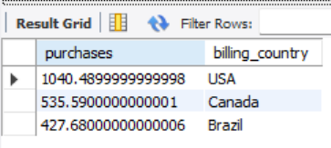

#Q2. What are the average prices of different types of music?

select g.name as genre,
sum(il.quantity*il.unit_price) /sum(il.quantity)as avg_price
from invoice_line il
join track t on il.track_id = t.track_id
join genre g on t.genre_id = g.genre_id
group by g.name;
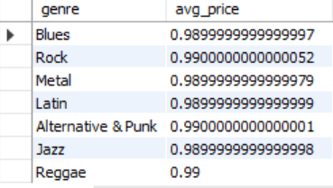
#-- Q3. Which is the most popular song
with sales as (
select sum(il.quantity*il.unit_price)as revenue,
t.name as song ,t.track_id as track_id from invoice_line il join track t
on il.track_id=t.track_id
group by t.name,t.track_id
)
select * from(select song,revenue, dense_rank() over(order by revenue desc)as rnk from sales )t
where rnk=1;
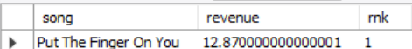
-- Q4. Write a query that determines the customer that has spent the most on music for each country.
with salesas as (
select sum(total)As spent ,
customer_id as cust_id,billing_country as country from invoice
group by customer_id,billing_country)
#query
select * from(select * ,dense_rank()over( partition by country order by spent desc)as rnk from salesas)t
where rnk=1 ;
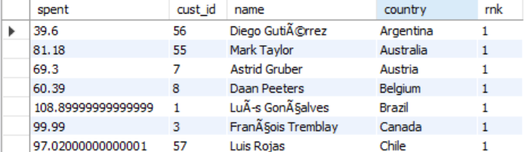
-- Q5. We want to find out the most popular music Genre for each country.
with revenue as (
select sum(il.quantity*il.unit_price)as rev, inv.billing_country as country,
g.name as genre
from invoice_line il join track t on il.track_id=t.track_id
join invoice inv on il.invoice_id=inv.invoice_id
join genre g on g.genre_id=t.genre_id
group by inv.billing_country,g.name)
#query
select * from(select * ,dense_rank()over(partition by country order by rev desc) as rnk from revenue)t
where rnk=1;
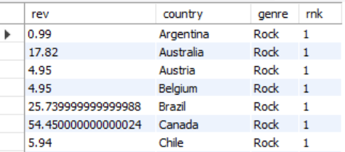

#Q6. Who is the best customer? The customer who has spent the most money will be declared the best customer.
select sum(total)As total_spent,customer_id from invoice group by customer_id order by total_spent desc limit 1;
#to have customer_name also
select inv.customer_id,c.full_name,sum(inv.total)as total_spent from invoice inv join customers c on
inv.customer_id=c.customer_id group by inv.customer_id,c.full_name order by total_spent desc limit 1;
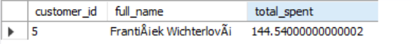
#Q7--Write a query that returns one city that has the highest sum of invoice totals. Return both the city name & sum
#of all invoice totals.
with totals as (
select sum(total)as total_gained ,billing_city from invoice group by billing_city
)
select * from(select total_gained,billing_city,dense_rank()over( order by total_gained desc)as rnk
from totals )t where rnk=1;
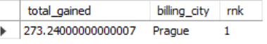
#Q8-What are top 3 values of total invoice?
select * from(select * ,
dense_rank()over(order by total desc)as rnk from invoice )t
where rnk<=3;
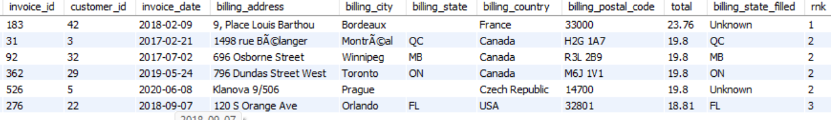
#Q9-Which countries have the most Invoices?
with most as (
select count(*)as counts,billing_country from invoice group by billing_country )
select * from(select *,dense_rank()over(order by counts desc)as rnk
from most)t
where rnk=1;
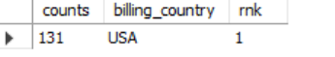

Q10.Who is the senior most employee based on job title?
select * from employees where title="General Manager";

#Q11-Write a query to return the email, first name, last name, & Genre of all ROCK
#Return your list ordered alphabetically by email starting with A

select distinct c.email,c.full_name,g.name from customers c join invoice inv on c.customer_id=inv.customer_id
join invoice_line il on il.invoice_id=inv.invoice_id
join track t on il.track_id=t.track_id
join genre g on t.genre_id=g.genre_id
where g.name="Rock"
order by c.email;
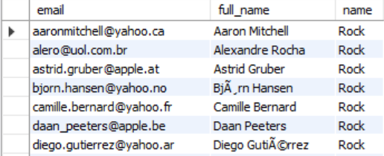

Q12.Find the top 3 customers who spent the most on Rock music
with top3 as (
select c.customer_id,c.full_name,sum(il.quantity*il.unit_price) as spent,g.name as genre from
customers c join invoice inv on c.customer_id=inv.customer_id
join invoice_line il on il.invoice_id=inv.invoice_id
join track t on il.track_id=t.track_id
join genre g on t.genre_id=g.genre_id
where g.name="Rock"
group by c.customer_id,c.full_name
)
select * from(select *,dense_rank()over(order by spent desc)as rnk
from top3 )t where rnk<=3 AND genre="Rock";
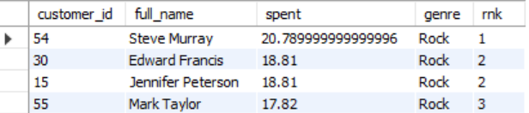
#Q13. Return all the track names that have a song length longer than the average song length.
-- Return the Name and Milliseconds for each track. Order by the song length with the longest songs listed first.
select name,milliseconds from track where milliseconds>(select avg(milliseconds) from track)
order by milliseconds desc;

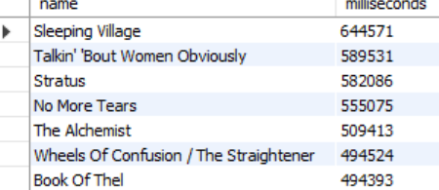

Q14.Top customers by spending
select c.customer_id,c.full_name,sum(inv.total)as spent from customers c join invoice inv on c.customer_id=inv.customer_id
group by c.customer_id,c.full_name order by spent desc limit 5;
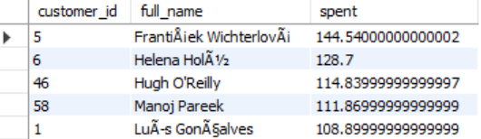
#Q15- Average Customer Lifetime Value
select avg(lifetime_value) as avg_customer_lifetime_value from(select sum(total)as lifetime_value, customer_id from invoice group by customer_id)t;
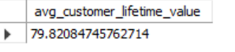
#Q16-Repeat vs One-time customers
select
case when count(invoice_id)=1 then "One Time Customers "
else "Repeat" end as re ,
c.customer_id,c.full_name
from invoice inv join customers c on c.customer_id=inv.customer_id group by c.customer_id,c.full_name;
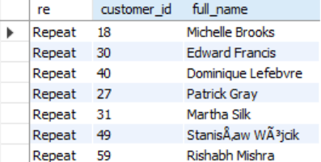

#Q17-Revenue per country
with rev as(
select sum(total)as revenue,inv.billing_country as country
from invoice_line il join invoice inv on il.invoice_id=inv.invoice_id
group by inv.billing_country)
#query
select revenue,country,
dense_rank()over( order by revenue desc)as rnk
from rev;
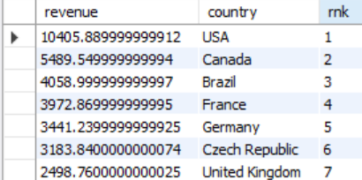

#Q18-avg rev per country
select billing_country,
sum(total)/count(distinct customer_id) as revenue_per_customer
from invoice
group by billing_country
order by revenue_per_customer desc;
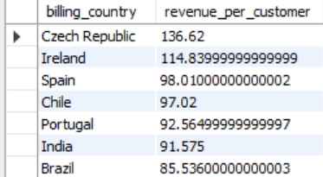

#Q19-Monthly revenue trend
select sum(il.quantity*il.unit_price)as rev,year(inv.invoice_date)As year,month(inv.invoice_date)as month
from invoice inv join invoice_line il on inv.invoice_id=il.invoice_id group by year(inv.invoice_date),month(inv.invoice_date)
order by year(inv.invoice_date),month(inv.invoice_date) ;
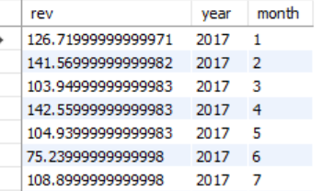

#Q20-rev by employee
select sum(inv.total)as rev,e.employee_id,e.full_name
from employees e
join customers c on e.employee_id=c.support_rep_id
join invoice inv on inv.customer_id=c.customer_id
group by e.employee_id,e.full_name
order by rev desc;
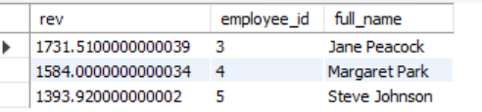

#Q21-top rev generating products
select sum(il.quantity*il.unit_price)as rev,t.name as track_name from invoice_line il join track t on il.track_id=t.track_id
group by t.name
order by rev desc;

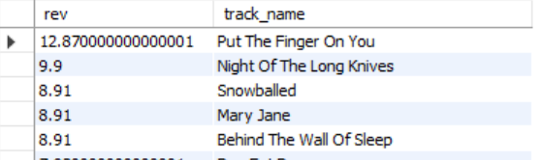
#Q22-Tracks never purchased
select name from track where track_id not in(select distinct track_id from invoice_line);
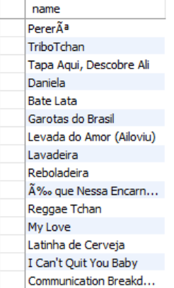
#Q23-avg price_per genre
select avg(t.unit_price)as avg_price,g.name as genre_name from track t join genre g
on g.genre_id=t.genre_id
group by g.name
order by avg_price;
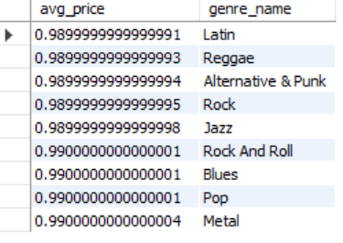
#Q24-Genre popularity (sales + revenue)
select g.name,
sum(il.quantity) as tracks_sold,
sum(il.unit_price * il.quantity) as revenue
from invoice_line il
join track t on il.track_id = t.track_id
join genre g on t.genre_id = g.genre_id
group by g.name
order by revenue desc;
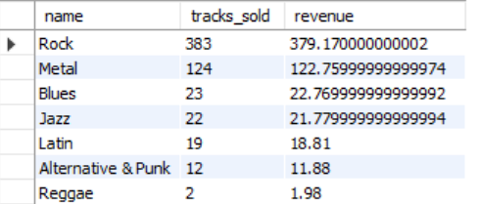

#Q25.rev by region
select sum(total)as spent ,billing_city from invoice group by billing_city order by spent desc;

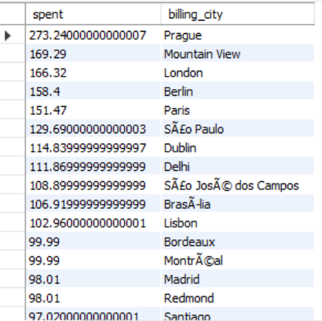
Q26---PURCHASE FREQUENCY
select customer_id,
count(invoice_id) as purchase_count
from invoice
group by customer_id
order by purchase_count desc;
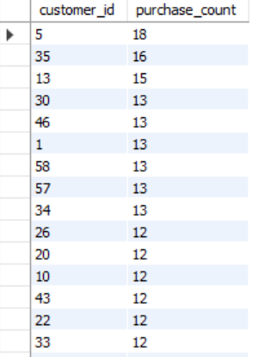

#Q27.avg time between purchases
select avg(datediff(invoice_date,lag_of) ) avg_difference,customer_id as Customer_ID from(
select c.customer_id,inv.invoice_date,lag(inv.invoice_date)over(partition by c.customer_id order by inv.invoice_date) as lag_of
from invoice inv join customers c on c.customer_id=inv.customer_id )t
where lag_of is not null group by customer_id;
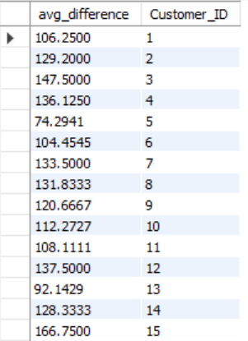

Q28.Top 3 customers per genre
with cte as (
select c.customer_id,
g.name as genre,
sum(il.unit_price * il.quantity) as spent,
dense_rank() over(partition by g.name order by sum(il.unit_price*il.quantity) desc) as rnk
from customers c
join invoice i on c.customer_id = i.customer_id
join invoice_line il on i.invoice_id = il.invoice_id
join track t on il.track_id = t.track_id
join genre g on t.genre_id = g.genre_id
group by c.customer_id, g.name
)
select * from cte where rnk <= 3;
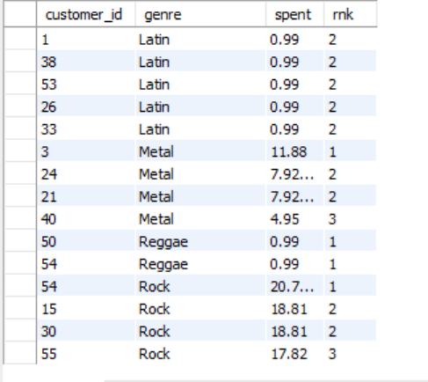
Q29—avg sales
with sales as (
select sum(il.quantity*il.unit_price)As reve ,invoice_date
from invoice inv join invoice_line il on inv.invoice_id=il.invoice_id
group by invoice_date)
#avg sales
select invoice_date,reve,
avg(reve)over(order by invoice_date) as avg_sales
from sales;
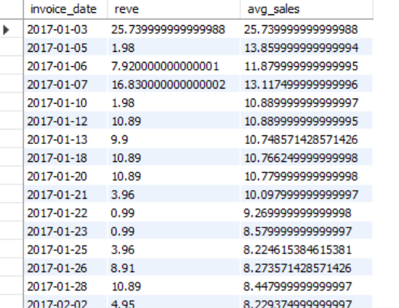

Q30—rolling sales
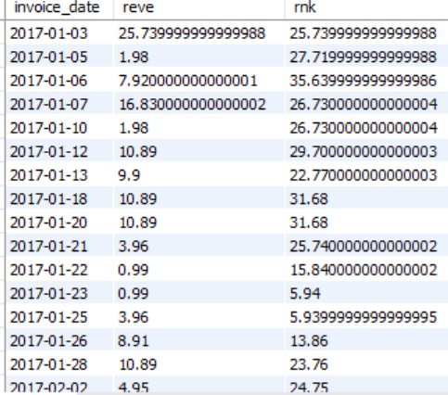

Q31.CUSTOMER RETENTION,CHURN RATES
with customer_purchases as (
select customer_id,invoice_date,
lead(invoice_date)over(partition by customer_id order by invoice_date)as nxt_purchase_date
from invoice),
ret as(
select customer_id,invoice_date,nxt_purchase_date,
datediff(nxt_purchase_date,invoice_date)as days_diff from customer_purchases
where nxt_purchase_date is not null
),
customer_status AS (
SELECT
customer_id,
MIN(days_diff) AS min_days_diff
FROM ret
GROUP BY customer_id
)
SELECT
COUNT(*) AS current_customers,

COUNT(CASE
WHEN min_days_diff <= 60 THEN 1
END) AS retained_customers,

COUNT(CASE
WHEN min_days_diff > 60 OR min_days_diff IS NULL THEN 1
END) AS churn_customers,

ROUND(
COUNT(CASE WHEN min_days_diff <= 60 THEN 1 END) * 100.0
/ COUNT(*), 2
) AS retention_rate

FROM customer_status;

